🌟 A Beginner-Friendly & Interesting Guide to Popular Shells and Terminal Tools

Understand their features, ease of access, and how friendly they are to use
When you open a terminal, you’re not just typing commands — you’re talking to a shell.
A shell interprets your words and gets things done behind the scenes. But not all shells feel the same.
Some are simple, some are super-smart, and some look so friendly that beginners fall in love instantly.
Let’s explore the most popular shells and tools in a way that’s clear, fun, and easy to learn — with a special focus on how accessible and user-friendly each one is. 🚀

🔵 1. Bash – The Classic, Simple, and Beginner-Friendly Shell
Bash is the default shell on most Linux systems — which already makes it easy to access everywhere.
Its commands are simple, predictable, and great for learning the basics of the command line.
Bash is stable, forgiving, and has tons of learning resources online, making it extremely beginner-friendly.
If you're just starting, Bash is the perfect comfort zone.
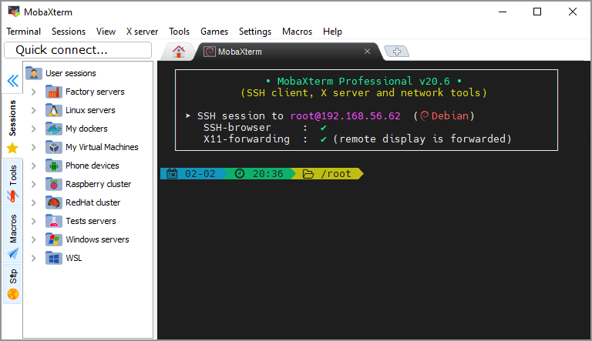

🟣 2. Zsh – Smart, Stylish, and Very User-Friendly
Zsh takes everything Bash has and adds intelligence — auto-suggestions, spelling fixes, themes, plugins.
It becomes even more accessible when paired with Oh My Zsh, which makes setup easy and visual.
The friendly interface, colorful prompts, and smart predictions make Zsh enjoyable even for new learners.
It feels modern, fast, and fun to work with.
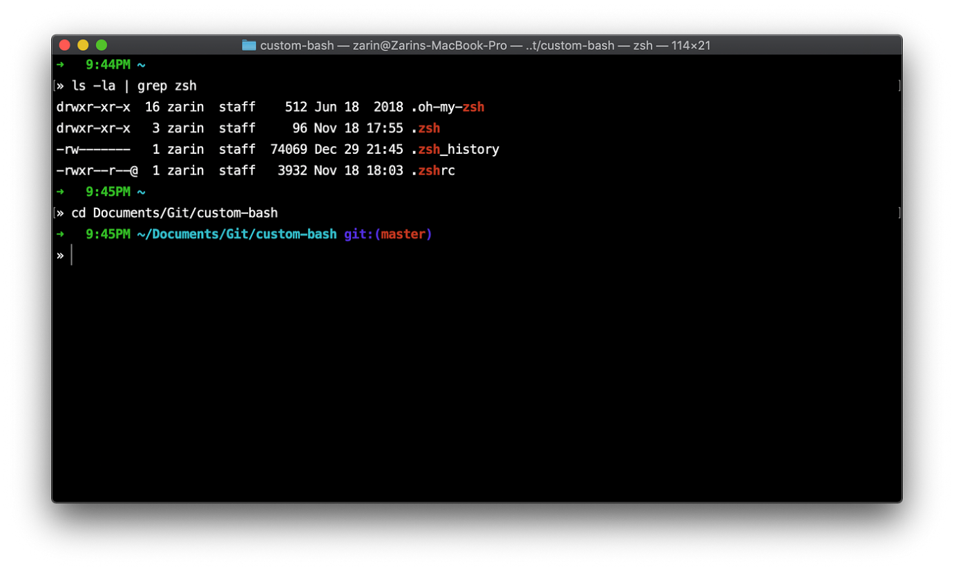

🟠 3. Fish – The Most Friendly Shell for New Users
Fish is designed around one idea: Make the terminal friendly.
No configuration, no confusion — it gives auto-suggestions, colour highlights, and readable prompts instantly.
Its web-based config tool also makes customization incredibly accessible.
If you want a shell that guides you naturally, Fish is one of the easiest and most pleasant to use.
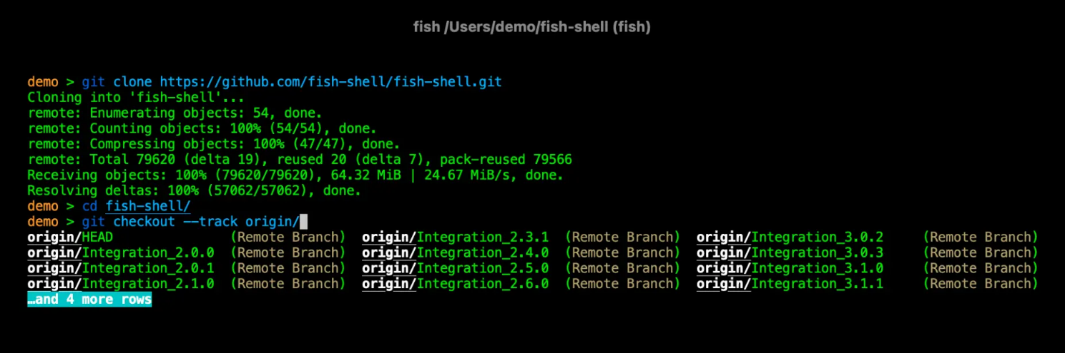

🟡 4. Ksh – Reliable, Stable, and Easy for Enterprise Work

Korn Shell (Ksh) shines in reliability and consistency.
It’s widely found in older Unix systems, making access easy if you work in enterprise environments.
Ksh is simple for scripting and stable enough for long-term production use.
While not flashy, it’s dependable and straightforward to learn.

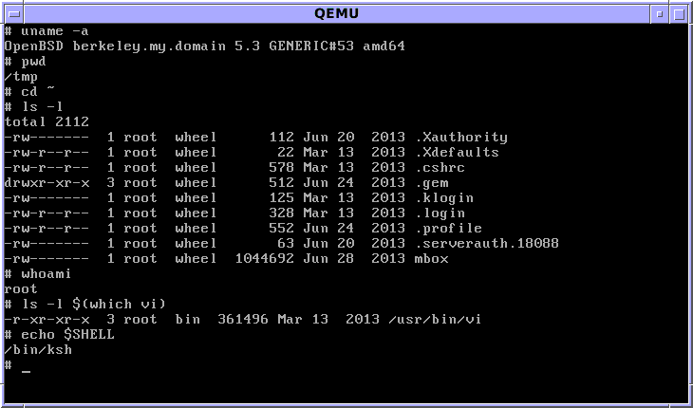

🔴 5. Tcsh – Structured, Predictable, and Friendly for C Programmers
Tcsh feels familiar to anyone who knows C language syntax.
Its command completion and scripting features make it predictable and easy to follow.
It’s widely used in academic environments, making it accessible in labs and institutions.
For learners who prefer logical structure, Tcsh is surprisingly friendly.
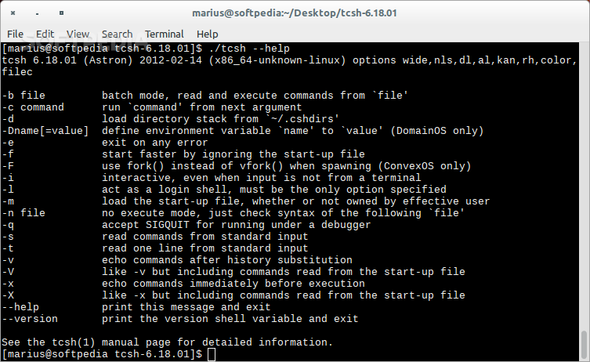

🖥️ Tools That Help You Access These Shells Easily
Some tools aren’t shells — they’re gateways that help you connect to shells on remote servers.
Let’s look at the tools that make remote access smoother and more user-friendly.

🟩 6. PuTTY – Simple, Lightweight & Easy for Beginners
PuTTY is one of the easiest SSH clients for Windows — no installation hassle, no complex setup.
Open it, type the server IP, click Connect, and you’re inside a shell.
Its lightweight design makes it perfect for students and beginners.
If you want easy and straightforward access to remote servers, PuTTY is a great start.

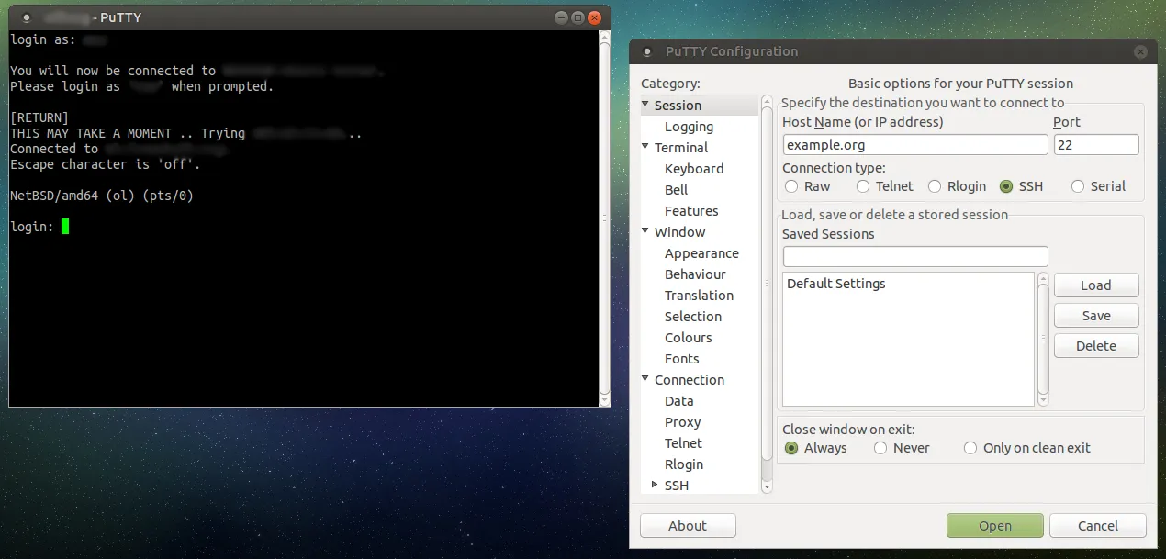

🟫 7. Git Bash – Familiar, Accessible & Great for Developers

Git Bash gives Windows users an instantly familiar Linux-like terminal.
It’s easy to install, lightweight, and supports most common Bash commands.
Perfect for developers working with Git, scripting, or automation.
Its simplicity makes it extremely user-friendly, even for people new to the command line.
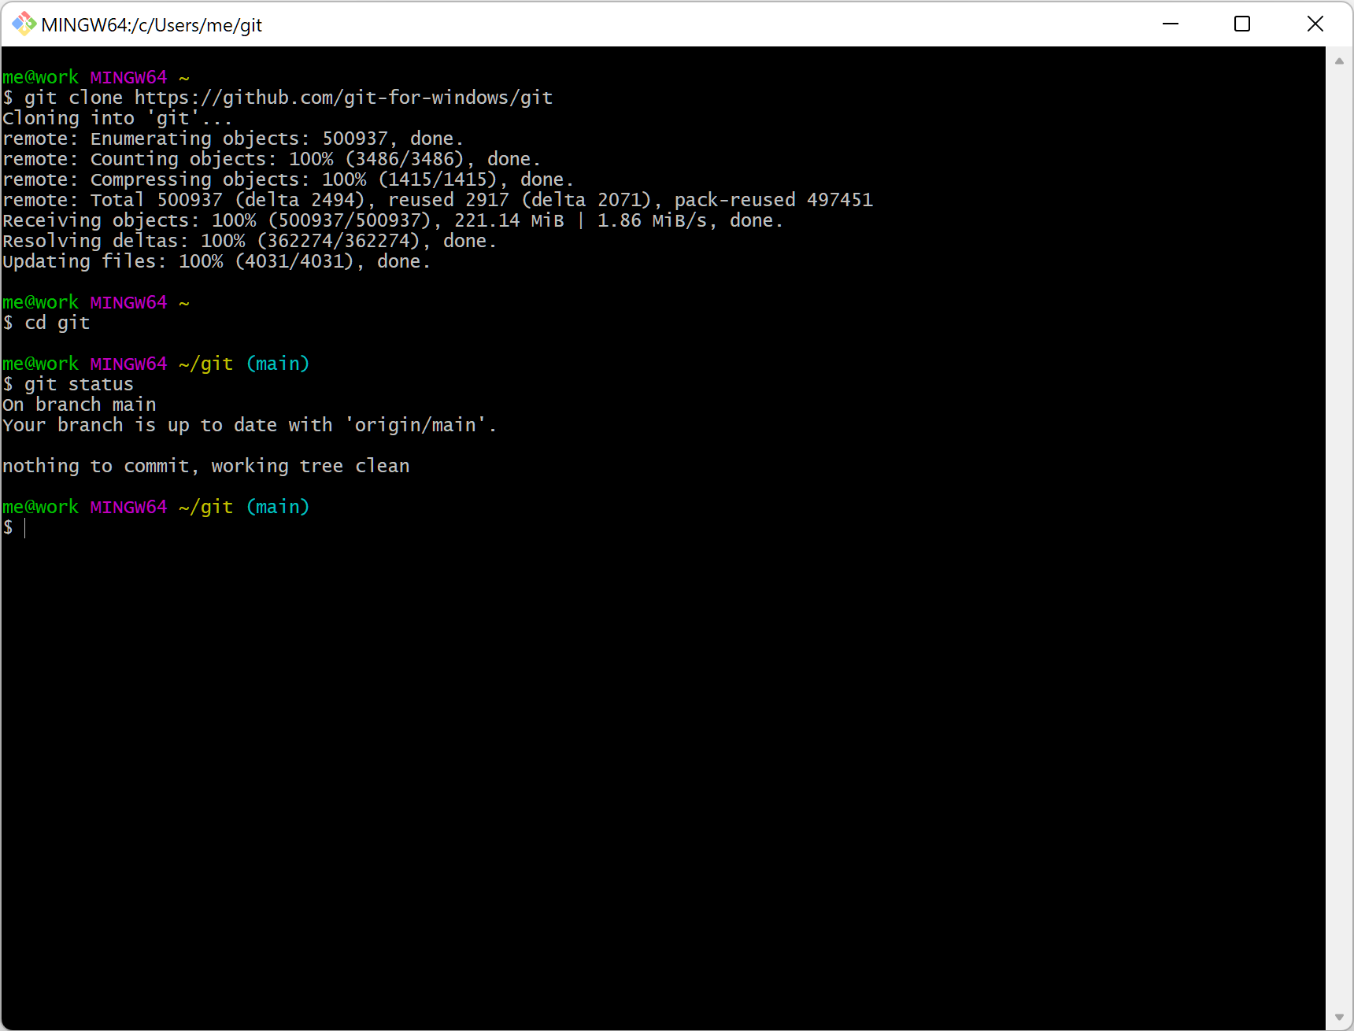

🔷 8. MobaXterm – All-in-One, Feature-Rich & Extremely User-Friendly
MobaXterm is the most accessible multi-purpose terminal tool for Windows.
You get SSH, SFTP, tabs, sessions, file transfer, and even graphical app support — all in one window.
Its interface is clean and intuitive, making remote server access easier than ever.
If you want power + ease + a friendly UI, MobaXterm is a champion.

🌱 Final Thoughts: Choosing What’s Best for You
Different shells offer different vibes:
✨ Bash → Simple, accessible, perfect for beginners
🎨 Zsh → Stylish, smart, fun, and super friendly
🤝 Fish → The easiest for comfort and guidance
🏢 Ksh → Reliable for enterprise
📘 Tcsh → Great for C-style learners
And in the world of terminal tools:
🚀 PuTTY is easy and lightweight
💻 Git Bash is familiar and developer-friendly
🧰 MobaXterm is the most feature-rich and friendly

Every tool brings its own charm — try them, explore them, and choose the one that feels natural to you.
That’s how learning becomes exciting. 🌟

